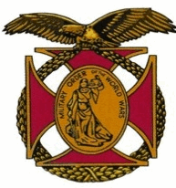

Meeting of the General J. P. Holland Chapter of the MOWW
February 6th, 2016

The Chapter met at the Bernardo Heights Country Club at 1100

The meeting was called to order at 1115 by Chapter Commander, Nick Herbka. Substitute Chaplain Carl Swepston offered the invocation and Earl Wentworth led the Pledge of allegiance. Tom Lettington read the Preamble.

Under “New Business”, Tom Lettington made a presentation of a Quilt of Valor to Companion Andre’ LeCault in honor of his service as a member of the US Army Rangers in Vietnam.

Lunch was served at 1200

After lunch the guest speaker, Companion Captain Royce Williams, USN (RET) gave a talk about his career in the US Navy and took questions.

Following his presentation, Nike Herbka present a Silver Patrick Henry Medallion to Royce Williams.

Carl Swepston gave the benediction, and the meeting was adjourned at 1340.

